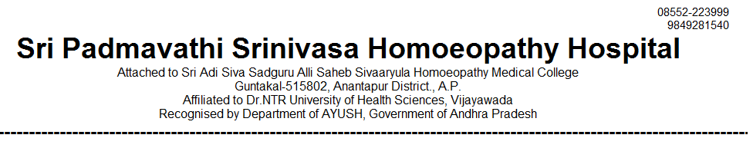
OUT PATIENT STATEMENT FOR THE YEAR JAN-2022 TO DEC - 2022

SNO | MONTH | GENERAL MEDICINE | GYNAECOLOGY /OBSTERICIAN | PAEDIATRICS | SURGERY | TOTAL
1 | 2022 - JAN | 2817 | 1392 | 1019 | 517 | 5745
2 | 2022 - FEB | 2876 | 1461 | 982 | 559 | 5878
3 | 2022 - MAR | 3297 | 1612 | 1114 | 575 | 6598
4 | 2022 - APR | 3062 | 1501 | 998 | 524 | 6085
5 | 2022 – MAY | 3152 | 1514 | 1015 | 591 | 6372
6 | 2022 – JUN | 3271 | 1580 | 1018 | 608 | 6477
7 | 2022 - JUL | 3306 | 1566 | 1040 | 595 | 6507
8 | 2022 - AUG | 3318 | 1624 | 1026 | 615 | 6583
9 | 2022 – SEP | 3495 | 1602 | 1070 | 608 | 6675
10 | 2022 – OCT | 3075 | 1550 | 1243 | 575 | 6443
11 | 2022 - NOV | 2961 | 1527 | 1159 | 596 | 6243
12 | 2022 - DEC | 3249 | 1678 | 1403 | 577 | 6907
